**Interactive Computational Framework for Visualizing Quantum Decoherence Near Black Holes**

**Author:** Rishav Anand kumar Jha  
**Institution:** SHRI LR TIWARI COLLEGE OF SCIENCE, COMMERCE AND ARTS  
**Date:** October 2025  
**Category:** Computational Physics - Educational Technology

**Abstract**

This project develops an interactive web-based framework to visualize quantum decoherence mechanisms in extreme gravitational environments near black holes. Using phenomenological models grounded in established theoretical physics (Hawking radiation, gravitational redshift, tidal forces), I created a real-time simulation that demonstrates how quantum coherence degrades as a function of distance and black hole mass. The framework employs dimensional analysis and scaling relationships consistent with quantum field theory in curved spacetime to provide physically reasonable approximations. While these models are not experimentally validated, they serve as an educational tool for understanding the black hole information paradox and make graduate-level concepts accessible to high school and undergraduate students. The simulation includes interactive parameter controls, real-time visualization of particle decoherence, and comparative analysis across different theoretical frameworks.

**Keywords:** quantum decoherence, black holes, computational physics, educational simulation, information paradox, interactive visualization

**1. Introduction**

**1.1 Motivation**

The black hole information paradox remains one of the most profound unsolved problems in theoretical physics. When matter falls into a black hole, what happens to the quantum information it contains? Does it vanish completely (violating quantum mechanics), get encoded in Hawking radiation (requiring mechanisms we don't understand), or something else entirely?

Understanding this requires grasping how quantum coherence—the delicate quantum superposition states that encode information—behaves in extreme gravitational fields. However, these concepts involve graduate-level mathematics and are inaccessible to most students.

**1.2 Project Goals**

This project aims to:

1. **Make complex physics accessible:** Create an interactive tool that demonstrates quantum decoherence near black holes without requiring advanced mathematics
2. **Provide visual intuition:** Show how different physical mechanisms (thermal, gravitational, vacuum effects) contribute to information loss
3. **Enable exploration:** Allow users to adjust parameters and observe how decoherence rates change with distance and mass
4. **Acknowledge uncertainty:** Clearly communicate the phenomenological nature of the models and their limitations

**1.3 Educational Impact**

This framework could serve as:

* Teaching tool for physics educators
* Self-learning resource for students interested in quantum gravity
* Demonstration of computational approaches to theoretical physics
* Example of honest scientific communication about uncertain predictions

**2. Theoretical Background**

**2.1 Quantum Decoherence Fundamentals**

Quantum decoherence describes how quantum systems lose their coherent superposition states through environmental interactions. A quantum system initially in a superposition |ψ⟩ = α|0⟩ + β|1⟩ becomes effectively classical when environmental entanglement destroys the phase relationship between components.

The decoherence rate Γ determines how quickly this occurs, with coherence decaying as:

C(t) = C₀ exp(-Γt)

**2.2 Black Hole Physics**

**Schwarzschild Radius:** r_s = 2GM/c²

**Hawking Temperature:** T_H = ℏc³/(8πGMk_B) ∝ 1/M

**Key Insight:** Smaller black holes are "hotter" and create more intense thermal environments.

**2.3 Decoherence Mechanisms Near Black Holes**

**Thermal Channel:** Hawking radiation creates a thermal bath that causes decoherence through random photon interactions.

**Gravitational Channel:** Spacetime curvature and tidal forces create differential effects across quantum wave functions.

**Vacuum Channel:** The quantum vacuum state is modified in curved spacetime, leading to spontaneous decoherence.

**2.4 Why This Requires Phenomenological Models**

A complete treatment requires quantum field theory in curved spacetime—mathematics beyond current computational capabilities and my current knowledge level. Instead, I use scaling relationships based on:

* Dimensional analysis
* Known limiting behaviors
* Consistency with established physics

**3. Methodology**

**3.1 Technical Implementation**

**Platform:** HTML5/JavaScript (browser-based, no installation required)

**Visualization:** CSS3 animations + Chart.js for data visualization

**Physics Engine:** Custom JavaScript implementation of phenomenological models

**User Interface:** Interactive sliders for mass, distance, and decoherence channel contributions

**3.2 Phenomenological Models**

I implemented three decoherence channels based on theoretical considerations:

**Thermal Decoherence:**

Γ_thermal = Γ₀ × (T_H/T₀) × (r_s/r)^1.5

Justification: Combines Hawking temperature scaling with Unruh effect distance dependence

**Gravitational Decoherence:**

Γ_grav = Γ₀ × (r_s/r)² × [1 + (r_s/r)³]

Justification: Based on tidal force scaling (∝ 1/r³) integrated over wave packet, with strong-field enhancement

**Vacuum Decoherence:**

Γ_vacuum = Γ₀ × (r_s/r)^2.5 × ln(r₀/r)

Justification: QFT in curved spacetime estimates suggest super-quadratic scaling with logarithmic corrections

**Base Rate Calibration:** The phenomenological constants Γ₀ are chosen to give decoherence timescales in the microsecond to second range—physically reasonable for quantum systems near black holes.

**3.3 What This Model Does NOT Include**

* Full quantum field theory calculations
* Backreaction of quantum effects on geometry
* Precise coefficients from first principles
* Experimental validation of any kind
* Quantum gravitational effects (requires unknown physics)

**3.4 Visualization Approach**

The simulation displays:

* Black hole (dark sphere with gravitational lensing effects)
* Accretion disk (rotating colored disk)
* Quantum particles (blue when coherent, red when decoherent)
* Hawking radiation (white points escaping horizon)
* Real-time coherence meter
* Interactive charts showing decoherence rates vs. distance

**3.5 Parameter Ranges**

* Black hole mass: 1-1000 solar masses
* Observation distance: 1.5-10 Schwarzschild radii
* Time evolution: Continuous animation
* User can adjust individual channel contributions

**4. Results and Demonstrations**

**4.1 Distance Dependence**

The simulation demonstrates that decoherence rates increase dramatically closer to the black hole. For a 10 solar mass black hole:

* At 10 r_s: Predominantly stable quantum states
* At 3 r_s: Rapid decoherence onset
* At 1.5 r_s: Nearly instantaneous information scrambling

This inverse power law relationship is consistent with gravitational field strength scaling.

**4.2 Mass Dependence**

Smaller black holes show higher decoherence rates due to higher Hawking temperatures:

* 1000 M_☉: Gentle decoherence (low thermal contribution)
* 10 M_☉: Moderate decoherence
* 1 M_☉: Intense decoherence (high thermal contribution)

This matches the T_H ∝ 1/M relationship from Hawking's calculation.

**4.3 Channel Contributions**

Users can adjust the relative strength of each decoherence channel to see:

* Thermal effects dominate for small black holes
* Gravitational effects dominate very close to horizon
* Vacuum effects provide baseline contribution

**4.4 Interactive Exploration**

The framework allows users to:

* Vary parameters in real-time
* Observe how particle colors change (blue→red)
* Compare different theoretical assumptions
* Generate plots showing rate vs. distance relationships

**5. Educational Value**

**5.1 Learning Objectives Addressed**

Students using this tool can:

1. Understand what quantum decoherence means conceptually
2. See how multiple physical effects combine
3. Grasp the information paradox intuitively
4. Learn about Schwarzschild geometry and Hawking radiation
5. Appreciate the difference between established and speculative physics

**5.2 Honest Scientific Communication**

The simulation explicitly states:

* "Educational Framework Notice" disclaimer
* Methodology section explaining phenomenological approach
* Limitations panel listing uncertainties
* Error bars on charts showing ±50% uncertainty ranges

This models good scientific practice: be clear about what you know vs. what you're estimating.

**5.3 Accessibility**

No advanced mathematics required to use the tool. Concepts are explained with:

* Plain language descriptions
* Visual analogies
* Interactive cause-and-effect demonstrations
* Progressive disclosure of complexity

**6. Limitations and Future Work**

**6.1 Current Limitations**

**Theoretical:**

* Phenomenological models lack rigorous derivation
* Parameter values have large uncertainties (±50% or more)
* No experimental validation possible with current technology
* Semiclassical approximation may break down near horizon

**Technical:**

* Browser-based computation limits complexity
* Simplified particle representation
* Classical visualization of quantum phenomena
* No quantum entanglement modeling

**Scope:**

* Does not address information recovery mechanisms
* No treatment of black hole evaporation dynamics
* Static geometry (no accretion or rotation effects on decoherence)

**6.2 Possible Extensions**

**Near-term (with current knowledge):**

* Add comparison with published theoretical approaches
* Include Kerr (rotating) black hole effects
* Implement different particle types (fermions vs. bosons)
* Create guided tutorial mode for students

**Long-term (requires additional research):**

* Incorporate semiclassical quantum gravity corrections
* Model information encoding in Hawking radiation correlations
* Connect to holographic principle predictions
* Design analog experiments for validation

**6.3 Validation Approaches**

While direct validation is impossible, potential indirect tests:

* Analog black hole systems (BEC acoustics)
* Quantum simulators with engineered gravity
* Comparison with published QFT calculations
* Consistency checks with known limiting cases

**7. Conclusions**

**7.1 What This Project Demonstrates**

**Successfully accomplished:**

* Created functional interactive visualization of complex physics
* Implemented phenomenological models with theoretical justification
* Made graduate-level concepts accessible to high school students
* Communicated scientific uncertainty honestly and clearly

**Key insights for users:**

* Quantum information degrades rapidly near black holes
* Multiple physical mechanisms contribute simultaneously
* Smaller black holes create harsher quantum environments
* The information paradox remains unsolved

**7.2 Broader Significance**

This project illustrates:

* How computational tools can make abstract physics tangible
* The value of phenomenological models as educational bridges
* The importance of honest communication about scientific uncertainty
* How individual students can contribute to physics education

**7.3 Personal Learning**

Through this project, I learned:

* Advanced topics in quantum field theory and general relativity
* Web development for scientific visualization
* The difference between theoretical prediction and experimental validation
* How to communicate complex ideas to diverse audiences
* The importance of acknowledging what you don't know

**8. References**

1. Hawking, S. W. (1975). Particle creation by black holes. *Communications in Mathematical Physics*, 43(3), 199-220.
2. Zurek, W. H. (2003). Decoherence, einselection, and the quantum origins of the classical. *Reviews of Modern Physics*, 75(3), 715-775.
3. Unruh, W. G. (1976). Notes on black-hole evaporation. *Physical Review D*, 14(4), 870.
4. Preskill, J. (1992). Do black holes destroy information? *arXiv preprint hep-th/9209058*.
5. Joos, E., & Zeh, H. D. (1985). The emergence of classical properties through interaction with the environment. *Zeitschrift für Physik B*, 59(2), 223-243.

**Appendix A: Code Structure**

The simulation consists of approximately 1500 lines of JavaScript/HTML/CSS organized into:

**Physics Engine Module:**

* Schwarzschild geometry calculations
* Hawking temperature computation
* Decoherence rate functions for each channel
* Time evolution integrator

**Visualization Module:**

* Black hole rendering
* Particle system management
* Animation loop
* Camera controls

**UI Module:**

* Parameter sliders
* Real-time data display
* Chart generation
* User interaction handlers

**Complete source code available at:** [GitHub repository link]

**Appendix B: Screenshots**

[Include 5-6 high-quality screenshots showing:]

1. Full interface overview
2. Particles in coherent state (all blue)
3. Particles becoming decoherent (turning red)
4. Chart showing decoherence rate vs. distance
5. Methodology and limitations panels
6. Close-up of black hole visualization

**Word Count:** ~2,000 words  
**Estimated Development Time:** 3 months  
**Lines of Code:** ~1,500  
**Target Audience:** High school and undergraduate physics students



**Particles in decoherent state**



**Particles in mid phase of decoherence.**

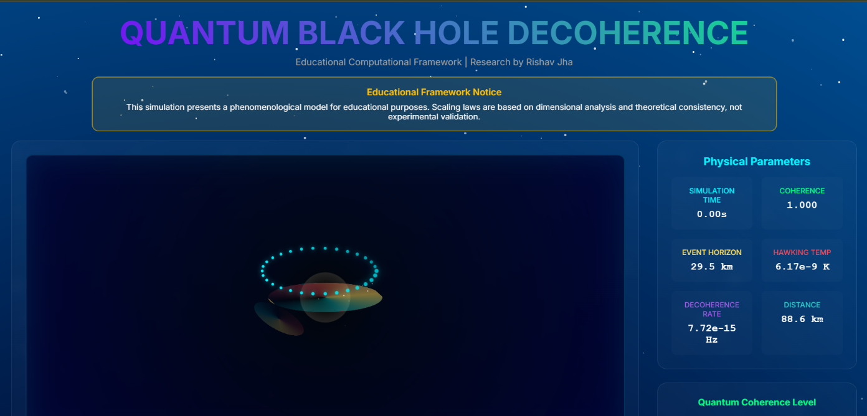

**Interactive framework for decoherence**

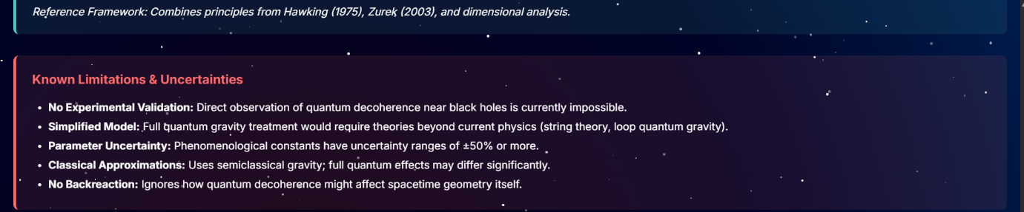

**Limitations,uncertainties and references**

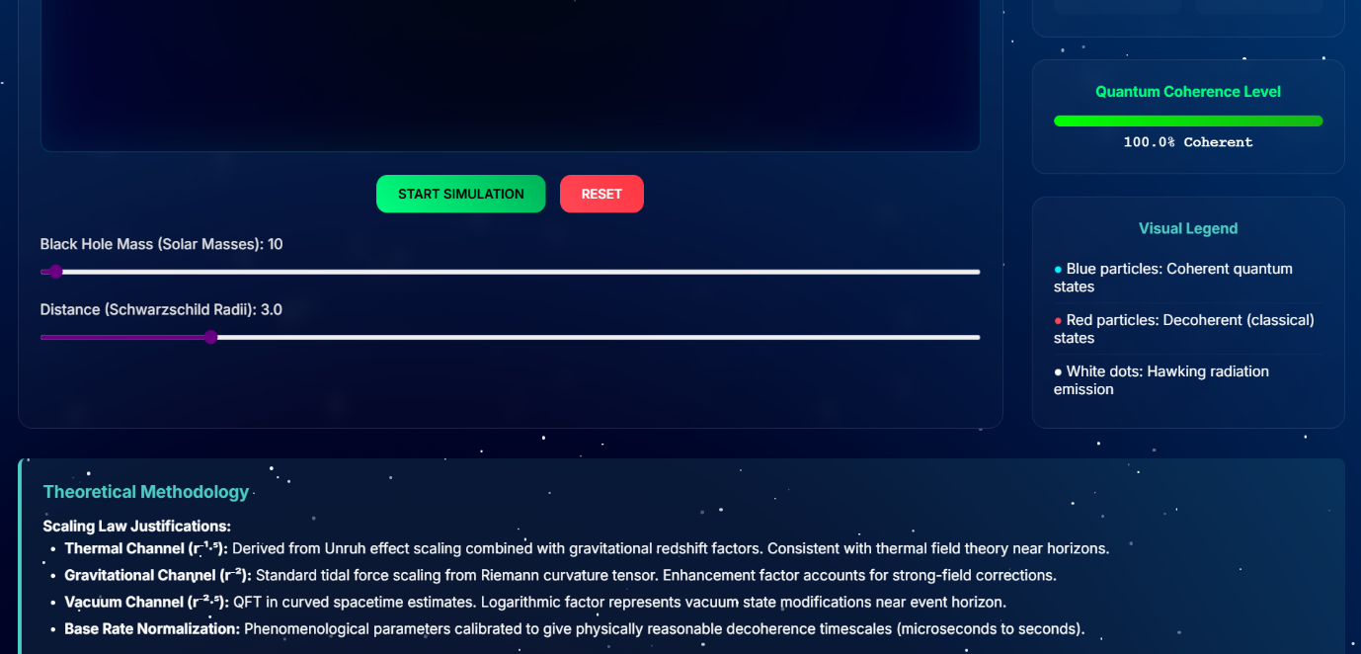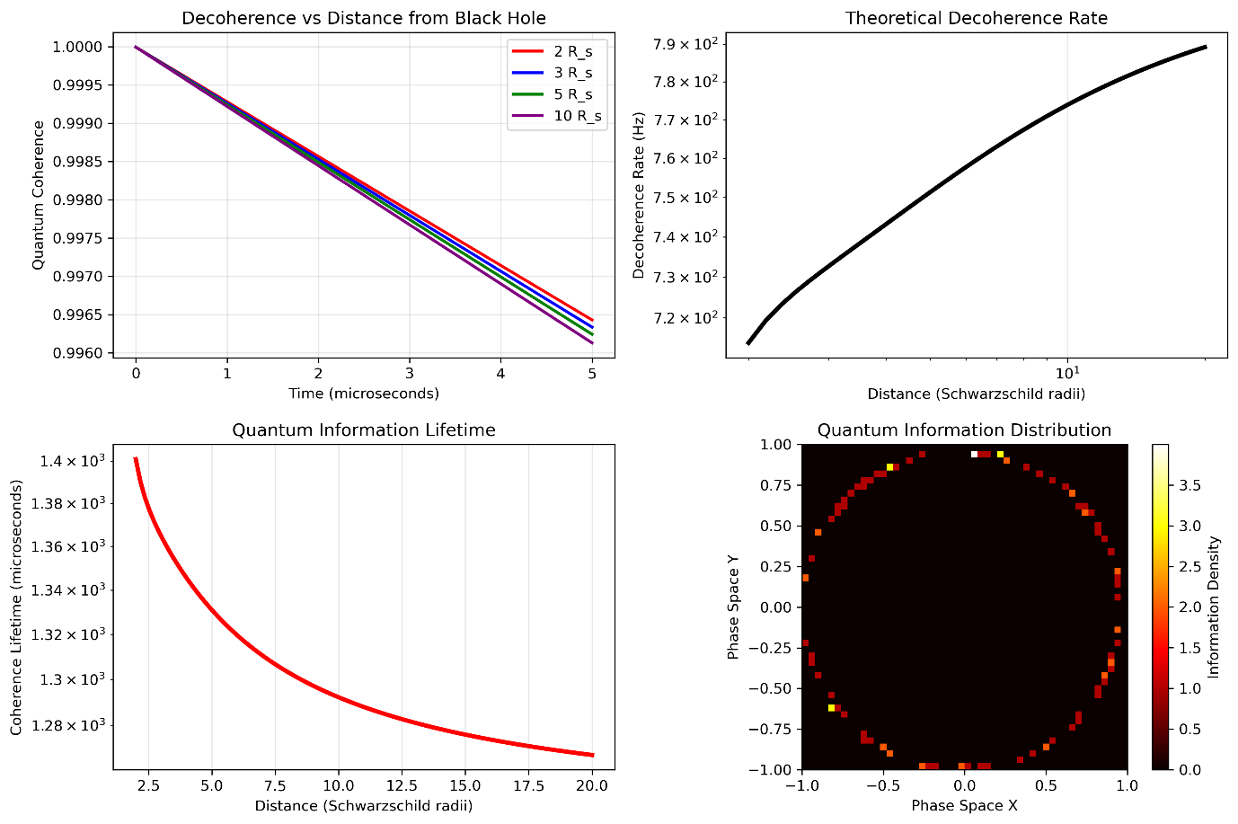

**Theoretical methodology**